NAME: TUFAIL AHMED B
ROLL NO: 241901119
EXPERIMENT 8
COLLECTING EMAIL EVIDENCE IN VICTIM PC
AIM
To collect and examine email evidence from a victim's computer for digital forensic investigation.
PROCEDURE
- Identify the computer or forensic image from which email evidence needs to be collected.
- Open a suitable digital forensic tool.
- Locate the email storage files or folders on the system.
- Identify the email client used on the computer, if applicable.
- Search for stored emails and related email data.
- Examine email details such as sender, receiver, subject, date, and time.
- Inspect email attachments and related files, where available.
- Preserve the collected email evidence without modifying the original data.
- Record the findings and document relevant email evidence for further investigation.

OBSERVATION
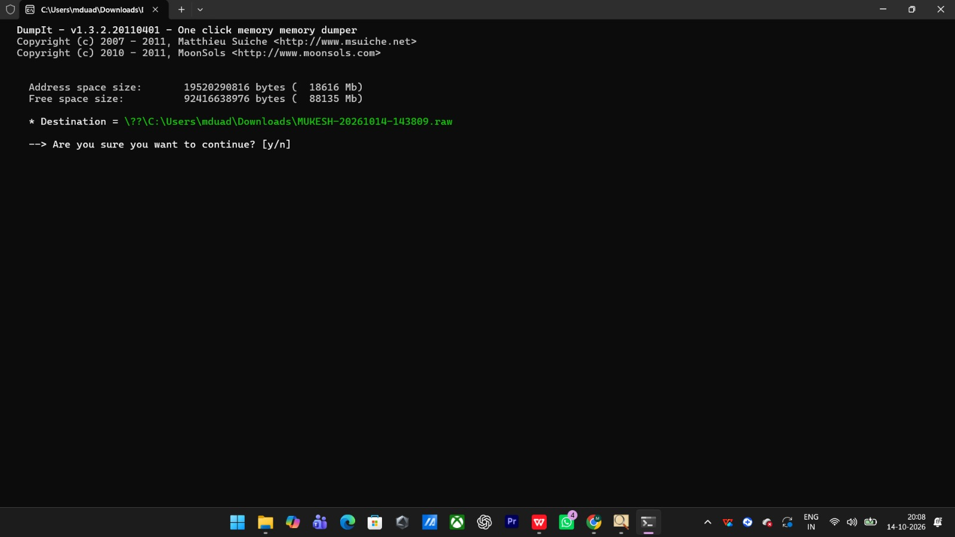

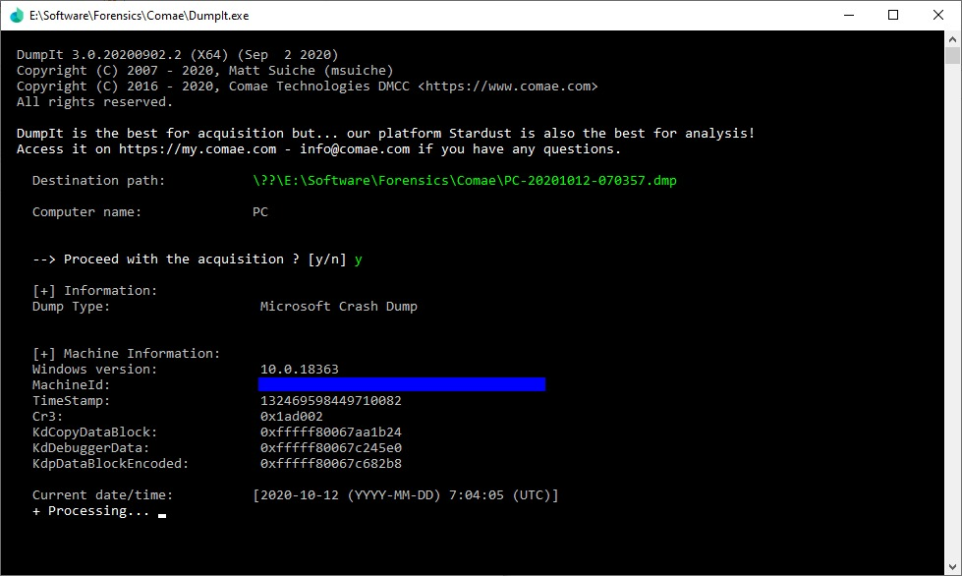

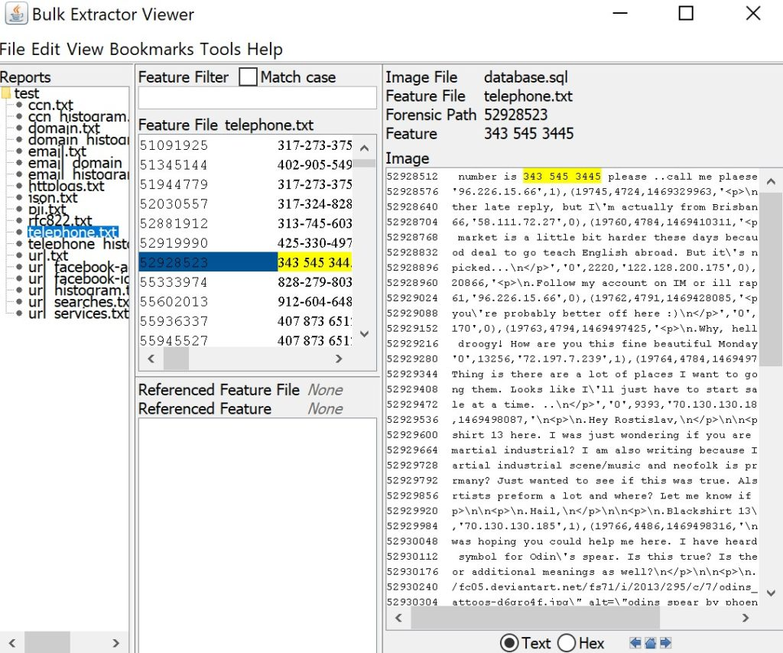
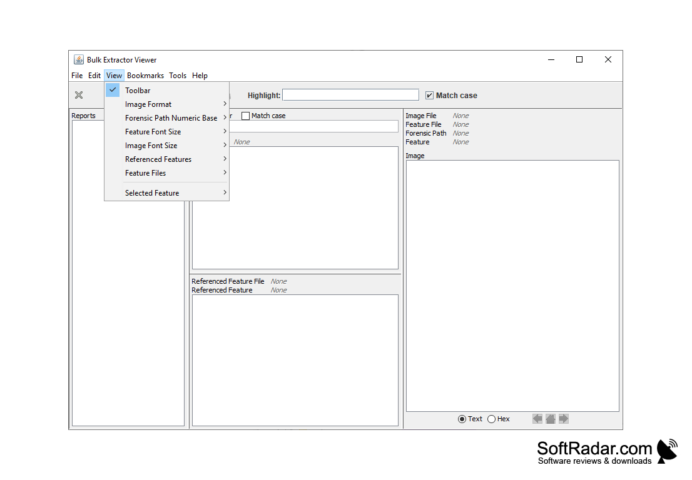

RESULT
Email evidence was collected and examined from the victim's computer for digital forensic investigation.

